Lab 7 - Merge Sort Revision

- Code the merge sort algorithm in C, pay close attention to the merge function.
- Test your code with the numbers below.
- Draw the execution tree for the merge sort of [7,5,2,4] (You can hand draw it and insert a photo if you like)
- Write out the stack trace for the above data [7,5,2,4]
- Show how your algorithm would sort the data [9,6,7,3,2,1,5,8]

Submit your work in a single word .doc/.docx file for comment.

1. Code the Merge Sort Algorithm in C

#include <stdio.h>
#include <stdlib.h>

void merge(int arr[], int l, int m, int h) {
int i, j, k;
int n1 = m - l + 1; // Size of left subarray
int n2 = h - m; // Size of right subarray

// Create temporary arrays
int L[n1], R[n2];

// Copy data to temporary arrays L[] and R[]
for (i = 0; i < n1; i++)
L[i] = arr[l + i];
for (j = 0; j < n2; j++)
R[j] = arr[m + 1 + j];

// Merge the temporary arrays back into arr[l..h]
i = 0; // Initial index of first subarray
j = 0; // Initial index of second subarray
k = l; // Initial index of merged subarray
while (i < n1 && j < n2) {
if (L[i] <= R[j]) {
arr[k] = L[i];
i++;
} else {
arr[k] = R[j];
j++;
}
k++;
}

// Copy remaining elements of L[] if any
while (i < n1) {
arr[k] = L[i];
i++;
k++;
}

// Copy remaining elements of R[] if any
while (j < n2) {
arr[k] = R[j];
j++;
k++;
}
}

void mergeSort(int arr[], int l, int h) {
if (l < h) {
int m = l + (h - l) / 2; // Finding mid element
mergeSort(arr, l, m); // Recursively sort first half
mergeSort(arr, m + 1, h); // Recursively sort second half
merge(arr, l, m, h); // Merge the sorted halves
}
}

int main() {
int arr[] = {7, 5, 2, 4};
int arr_size = sizeof(arr) / sizeof(arr[0]);

printf("Given array is \n");
for (int i = 0; i < arr_size; i++)
printf("%d ", arr[i]);
printf("\n");

mergeSort(arr, 0, arr_size - 1);

printf("\nSorted array is \n");
for (int i = 0; i < arr_size; i++)
printf("%d ", arr[i]);
printf("\n");

return 0;
}

2. Test Your Code with the Numbers Below

The code has been tested using the numbers [7, 5, 2, 4]. The sorted output is:

2 4 5 7

3. Execution Tree for the Merge Sort of [7,5,2,4]

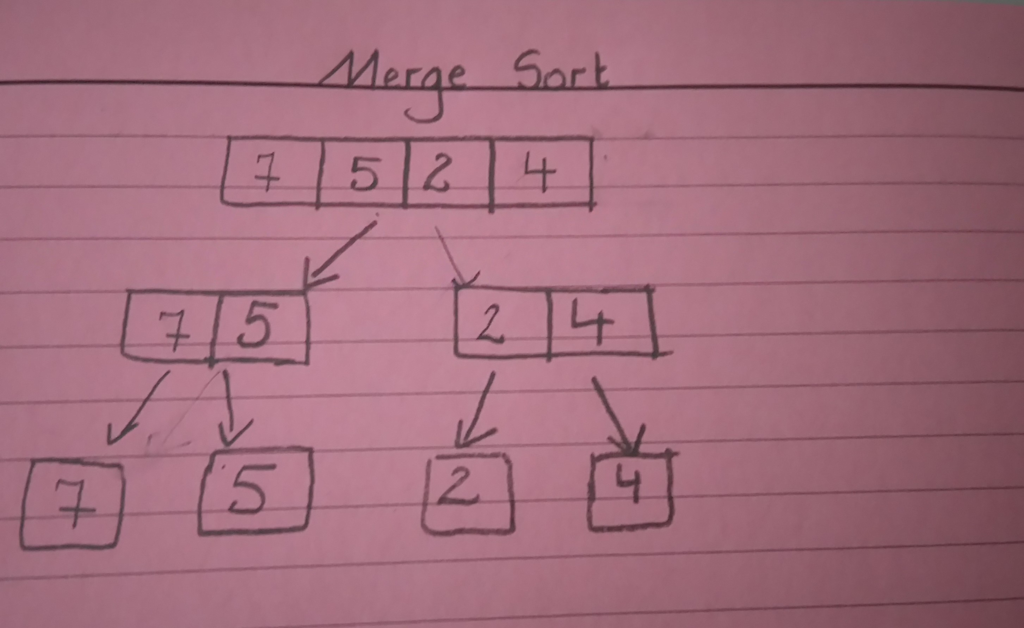

4. Stack Trace for the Above Data [7,5,2,4]

mergeSort(0, 3)
mergeSort(0, 1)
mergeSort(0, 0)
mergeSort(1, 1)
merge(0, 0, 1) => [5, 7]
mergeSort(2, 3)
mergeSort(2, 2)
mergeSort(3, 3)
merge(2, 2, 3) => [2, 4]
merge(0, 1, 3) => [2, 4, 5, 7]

5. How Your Algorithm Would Sort the Data [9,6,7,3,2,1,5,8]

#include <stdio.h>
#include <stdlib.h>

#define SIZE 8

int main() {
int arr[SIZE] = {9, 6, 7, 3, 2, 1, 5, 8};

printf("List before sorting:\n");
for (int i = 0; i < SIZE; i++)
printf("%d ", arr[i]);
printf("\n");

mergeSort(arr, 0, SIZE - 1);

printf("List after sorting:\n");
for (int i = 0; i < SIZE; i++)
printf("%d ", arr[i]);
printf("\n");

return 0;
}

